photoplethys-mogram amplifier

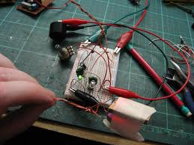

General:

The photoplethysmographic sensor will be placed below the tip of the finger and pressure will be applied on the proximal phalanx. Since the cuff is wrapped on the proximal phalanx of the finger rather than arm, it makes less discomfort for prolonged used. The blood volume changes on the finger will be notified by the sensor and transmitted to the system by Bluetooth transmitter.

There is a timer attached on the device to time the cuff pressure applied time and transmitter so that it is semi-continuous measurement. This is because to decrease the energy consumption of Bluetooth transmission and to avoid discomfort of the wearer’s finger due to continuous pressure applied. The idea of the blood pressure sensor is much like the Photoplethysmograph Fingernail Sensor for measurement of finger force which is mentioned in a journal by Stephen A. Mascaro and H. Harry Asada [2]. The finger force is measuring colouration of fingernail by using reflectance photoplethysmography. The sensor is made into a hand glove as a more compact device. Below is the picture of the fingernail sensor.

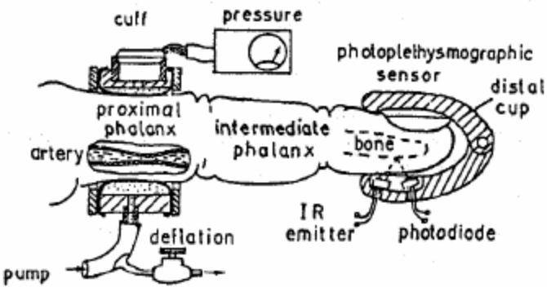

There is a timer attached on the device to time the cuff pressure applied time and transmitter so that it is semi-continuous measurement. This is because to decrease the energy consumption of Bluetooth transmission and to avoid discomfort of the wearer’s finger due to continuous pressure applied.
The idea of the blood pressure sensor is much like the Photoplethysmograph Fingernail Sensor for measurement of finger force which is mentioned in a journal by Stephen A. Mascaro and H. HarryAsada [2]. The finger force is measuring colouration of fingernail by using reflectance photoplethysmography. The sensor is made into a hand glove as a more compact device. Below is the picture of the fingernail sensor.

Design Elements Size/Profile:

In order to fulfill the requirement reduce discomfort of the wearer, the sensor must be thin and unobtrusive. If possible, the sensor can be made in decorative manner such that it is not obvious to the others. Besides that, the sensor should not be obtrusive to the wearer’s daily activities.
Sensor Position:

Separation between noise and signal is the most crucial part of the sensor position. It is proposed to be attached rigidly to the fingernail. This will reduce the background noise of sensor. The interface between the finger and the sensor must be optically transparent to increase the sensitivity of the sensor.

Shielding of Ambient Light:

Due to the sensitivity of the sensor to light, the shielding of the sensor is difficult. Photodiodes has to be optically shielded from the ambient light to reduce noise caused by the ambient light. Photodiode detector has to be shielded from the side to prevent unwanted light from the infrared emitter. This will avoids unwanted voltage from forming.

Signal Processing and Transmission:

An amplifier such as below is located near to the photodiode detector to amplify signal from the detector. This is to prevent loss of signal due to long transmission. The amplified signal will be processed and transmitted to the system by using Bluetooth transmitter. The figures below show the amplifier circuit of the PPG sensor and the transmission flowchart of the PPG sensor.

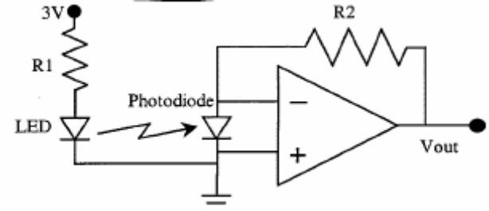

Method of Measurement:

There are two methods suggested by Ante Fiantii and Miroslav Gaban to measure the diastolic and systolic blood pressure on the finger [3]. One of them is based on measurement of pulse time-delay between proximal cuff and distal photoplethysmograph sensor. The other method is based on pulse amplitude differences which occur during the cuff deflation.
The systolic pressure can be easily determined with the sensor on the tip of the finger. The proximal cuff deflates and when the systolic pressure in the proximal cuff is reached, the first bolus of blood succeeds to reach sensor, what indicate systolic pressure. However, it is harder for determination of diastolic pressure measurement.
Pulse Time Delay Method:

In the previous work of Fiantii and Miroslav Gaban mentions about the method of measuring the time delay of the transition between proximal cuff and sensor until it becomes constant [3]. Refer to the figure below, the time delay can be measured in Δt.

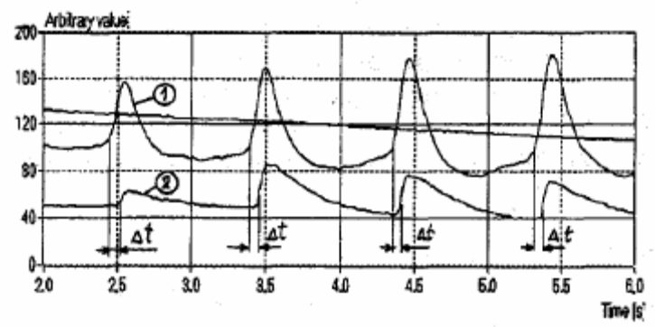
Pulse pressure signal in the proximal cuff 1 and photoplethysmograph sensor 2 near systolic pressure

However, if we notice different time pulse delay has different peak value. In previous work by A.Santic, M.R. Neuman, the less changed peak amplitude is taken. Refer to the figure below; the peak amplitude corresponding to the first minimum of time pulse changes is taken.
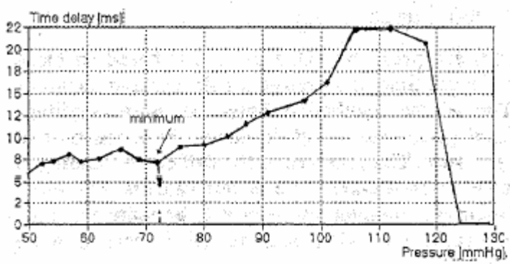

Pulse time delay as a function of pressure in the proximal cuff

Pulse Amplitude Difference Method:

The amplitude differences (between cuff pressure and sensor) obtained after the systolic pressure is the highest systolic pressure. The amplitude differences obtained after the diastolic pressure is the lowest pressure. Refer to the figure below to see the graph of pulse signal.

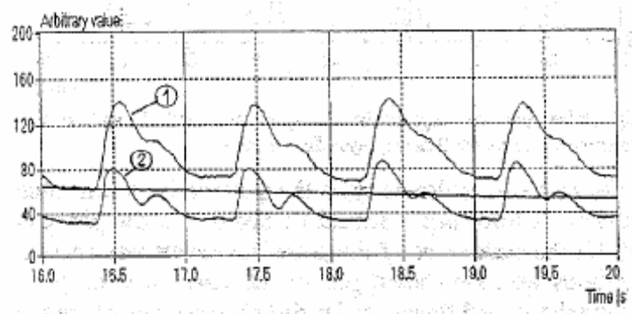

Pulse pressure signals in the proximal cuff 1 and photoplethysmograph sensor 2 near diastolic pressure with shown amplitude differences

